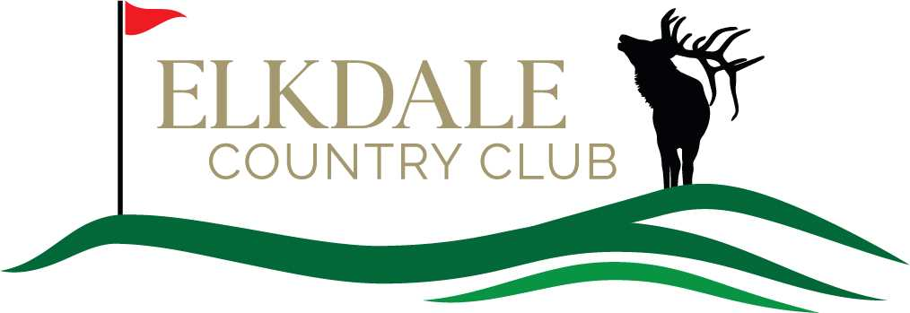

Junior Golf Program for junior boys and girls ages 7 – 17
Dates: Thursday July 11 - Thursday August 22nd. Meet us at the golf shop at 8:15am.
Cost: $70.00
***************************************************************************
Junior Golfers Name: _______________________________ Age: __________
Address: _________________________________________
_________________________________________________ Phone: __________________
Boy / Girl Polo shirt size: ____________ (polo shirt & hat will be provided for the junior golfers. Please have your golfers wear them on lesson days and anytime they play the course. “Look Sharp - Feel Sharp - Play Sharp”.)
Parental Signature: ______________________________________ Date: __________
Parents and Grandparents are encouraged to volunteer as a coach and mentor for this program. Please check the box below if you are willing to donate your time to a great cause.

YES, I will be a volunteer.

Please stop into the Elkdale Golf Shop with your registration form and introduce us to your Junior Golfer.
OR Mail registration form with payment to: Elkdale Country Club
P.O. Box 544

Salamanca, New York 14779
Attn: Janice Mendell – Junior Clinic
Registration forms and payment must be received by June 15^{th.}
Visit www.elkdalecc.com for program details.

